Conserving Energy Lesson Plan
Fourth Grade

Objective
- Describe the different forms of energy.
- Identify ways that energy is converted from one form to another.
- Determine that sunlight is the primary source of most of the usable energy on Earth.
- Students will be able to compare/contrast different sources of energy and make an informed decision about which energy source is best for the imaginary town of Power City.
Standards
4PS3-2 Make observations to provide evidence that energy can be transferred from place to place by sound, light, heat, and electric currents.
4PS3-3 Apply scientific ideas to design, test, and refine a device that converts energy from one form to another
4ESS-3 Obtain and combine information to describe that energy and fuels are derived from natural resources and their uses affect the environment.
Vocabulary
chemical energy, electrical current, energy, fossil fuel, global warming, gravitational potential energy, hydroelectricity, kinetic energy, light, nonrenewable resource, nuclear energy, renewable resource, sound, thermal energy
Materials
- https://www.youtube.com/watch?v=4zYjAUqRCL8 (Wasting Energy)
- Gizmo: Energy Conversion (explorelearning.com)
- Energy worksheet
- Powerpoint
- Internet websquest: https://www.denmark.k12.wi.us/faculty/kraschnl/energyhome2.html
- Staff survey

Procedure
- Discuss what students learned when we explored Energy Conversions in our Gizmo during Unit 1.
- Show a short video on wasting energy to get students thinking about conserving energy.
- Discuss ways we save energy in our homes and at school.
- Teach renewable vs. nonrenewable with a money comparison. “Pretend I have $100 in my pocket. If I go to the store and spend my money, I never get it back. This is a lot like nonrenewable energy such as coal and oil. Once we run out, there’s no going back for more. Renewable sources like wind, water, and solar always give back and never run out, like keeping that $100 in your pocket.”
- Put students into groups of 4. Each student will be assigned as an Engineer. Each engineer will need to research his/her assigned energy sources and complete an energy worksheet explaining how it works, advantages, and disadvantages.
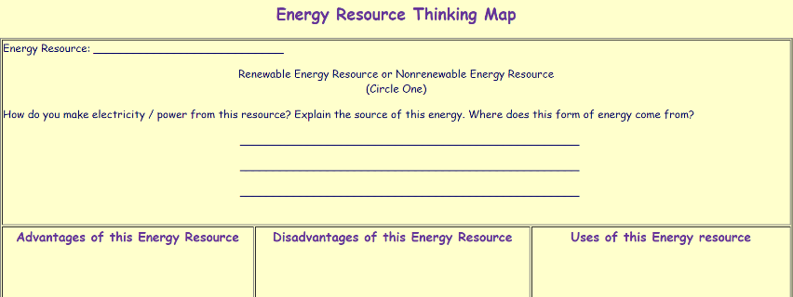
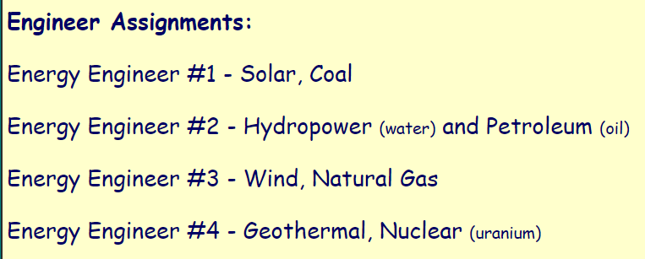

- After all group members have completed their research, show students “Power City.” Team members need to study the location and surrounding environment of Power City. After studying the area and available resources, the team will decide which renewable and nonrenewable energy resource should be used for the city to produce electricity. Each group will present their choices and reasons to the class.
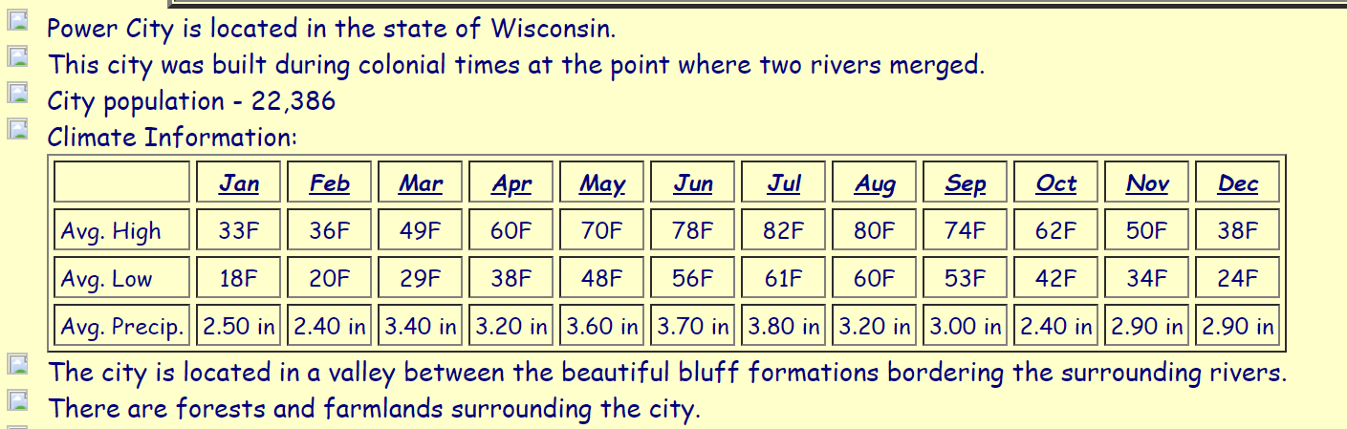

Extension
Students can survey teachers and staff members on their energy usage, find trends in the data, and discuss possible solutions to any areas where staff could save more energy.
