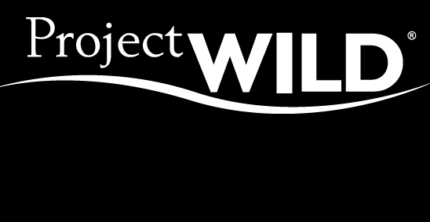

Certificate of
Professional Development in
Wildlife Education

Presented to

Josefina Rodriguez
In Recognition of Successful Completion of a

Project WILD Educator Workshop

Bruce Travers, Aurelio Giannitti, & Gerrie Wiersberg June 15th, 2017

Project WILD Facilitators Date


