***LIGHT SOURCES SORT***

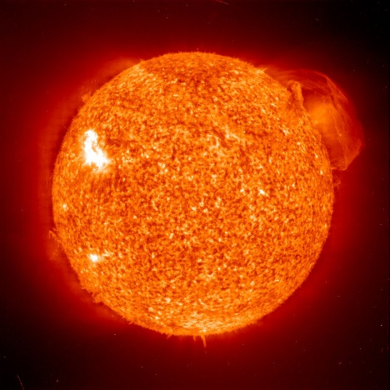 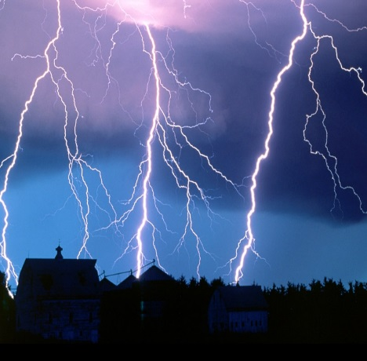 [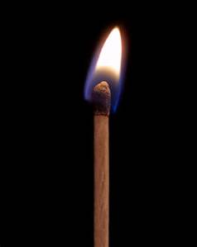](http://www.bing.com/images/search?q=match&view=detailv2&adlt=strict&id=690E4008965874640D64668E4F478BE51830E6E3&selectedIndex=5&ccid=GLF2o/gV&simid=608047970105884977&thid=OIP.M18b176a3f815beca72de719c8f0af639H0) [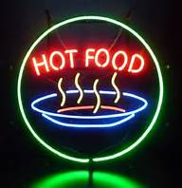](http://www.bing.com/images/search?q=neon+food+sign&view=detailv2&&id=A147E4370161D55BFE30EC18495432933992EE08&selectedIndex=13&ccid=61TUJ%2bDg&simid=608023085061966806&thid=OIP.Meb54d427e0e0e55c8c7b77b47217a9c1o0) [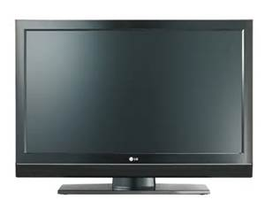](http://www.bing.com/images/search?q=television&view=detailv2&adlt=strict&id=F7DF4908588E76687FD71530A4B1695AB3F0DE57&selectedIndex=1&ccid=r5a10YW8&simid=608001863624951499&thid=OIP.Maf96b5d185bc3995568993578cf1f59aH0) [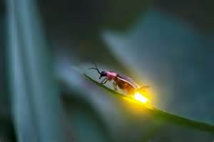](http://www.bing.com/images/search?q=naturally+luminescent+animals&view=detailv2&&id=E7160623B57B9ACC0C2551B13DB0DF480FE648D9&selectedIndex=5&ccid=d6vSyhUP&simid=608013125034117882&thid=OIP.M77abd2ca150f898429ff9a482dac9653o0) [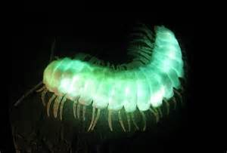](http://www.bing.com/images/search?q=naturally+luminescent+animals&view=detailv2&&id=DB517A4B99F89F3012DE6EBB82C01AB4ABDCC527&selectedIndex=14&ccid=vbG%2bTQPL&simid=608027453043968651&thid=OIP.Mbdb1be4d03cb264cdf36c7af8e2b222fH0) [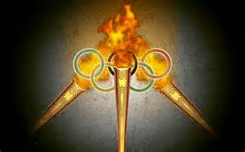](http://www.bing.com/images/search?q=olympic+torch&view=detailv2&&id=902B029F9F3EE3B3322430C905933499582AC326&selectedIndex=45&ccid=fk2Ht/z7&simid=608052170575578881&thid=OIP.M7e4d87b7fcfbd8a44e43cd7413b4a34fo0) [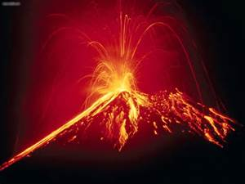](http://www.bing.com/images/search?q=lava+volcano&view=detailv2&&id=25AE7C3F4E500D02A90E01AB4923327A6DF8DD8E&selectedIndex=11&ccid=hVpN/yhZ&simid=608001824967558496&thid=OIP.M855a4dff285958ba8a091d702a63f7c6H0) [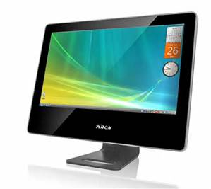](http://www.bing.com/images/search?q=computer&view=detailv2&&id=2064D23AB3BCB20096034ED4E549217C8378FBE6&selectedIndex=0&ccid=Z7IcI0DF&simid=608053970167727517&thid=OIP.M67b21c2340c55d0005a3793d14d3bd38H0) [](http://www.bing.com/images/search?q=camera+flash&view=detailv2&&id=17ABE646B44B02290C814CA5B1182EE3DA18ABB7&selectedIndex=16&ccid=xDJh0MYP&simid=608022818774649648&thid=OIP.M6cea2398e2afb5d2637047863e2ed072o0) [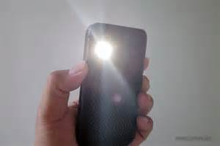](http://www.bing.com/images/search?q=phone+flashlight&view=detailv2&&id=654CEE0CD064C4DE25499E6611F94E03F64203EA&selectedIndex=91&ccid=xCyG/m0Z&simid=608055456233753662&thid=OIP.Mc42c86fe6d1982a4691041b5cc705eb1o0) [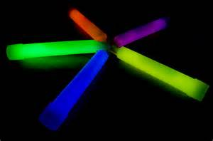](http://www.bing.com/images/search?q=glow+sticks&view=detailv2&&id=721BF6AA4ECF50A20915C85D44F9FB31B8F81AA2&selectedIndex=14&ccid=vb09u6Gt&simid=608041282841216495&thid=OIP.Mbdbd3dbba1ade406d5b4485b8dd39456o0) [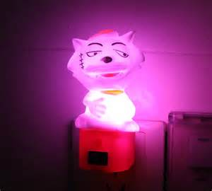](http://www.bing.com/images/search?q=night+light&view=detailv2&&id=54CDE3E863295638CC4DC50AAEEB949B0A172998&selectedIndex=50&ccid=1fVMTM1n&simid=608036880498229808&thid=OIP.Md5f54c4ccd67a9af8e767eadca407209o0) [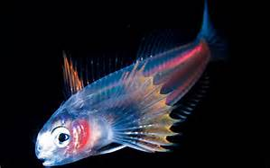](http://www.bing.com/images/search?q=naturally+luminescent+animals&view=detailv2&&id=CA2C0C266907DFA21B9D48C9F0D81EFE32310F46&selectedIndex=28&ccid=zsns%2b8PH&simid=608018476561466795&thid=OIP.Mcec9ecfbc3c7371265ed2584728d07c9o0) [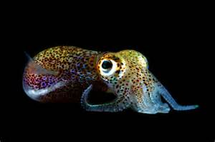](http://www.bing.com/images/search?q=naturally+luminescent+animals&view=detailv2&&id=879730F600F0F99AE1E52A73437B6E94CE32245C&selectedIndex=12&ccid=emgGZ78J&simid=608001700432776173&thid=OIP.M7a680667bf090619bad0b75f27d5ef3do0) [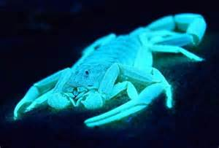](http://www.bing.com/images/search?q=naturally+luminescent+animals&view=detailv2&&id=5BAE065CA1E672B04EF0297FB0DEF2802EE36787&selectedIndex=6&ccid=UkJKKjBU&simid=607988699553204832&thid=OIP.M52424a2a305463ce3b176c375312f845o0) [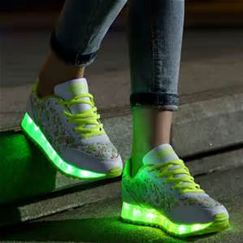](http://www.bing.com/images/search?q=light+up+sneakers&view=detailv2&&id=B8D88948353CB4DD14D76B40C8BD377629E9515C&selectedIndex=10&ccid=YZMTVAnW&simid=608016234582445952&thid=OIP.M6193135409d6e8fa4ff66df18ed72c61o0)

[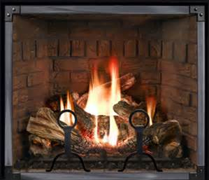](http://www.bing.com/images/search?q=fireplace&view=detailv2&&id=1127F51BF6C4000FD876DA0B33A39EA37B5886D8&selectedIndex=11&ccid=jbsqcosP&simid=608003762006458683&thid=OIP.M8dbb2a728b0fedd9f390b05d394af21aH0)[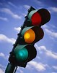](http://www.bing.com/images/search?q=traffic+light&id=008A41DF1EB4BC39BB179F962464DB740E4B176E&FORM=IQFRBA) [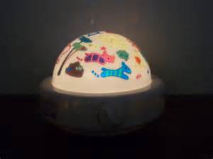](http://www.bing.com/images/search?q=lullaby+light+at+night&view=detailv2&&id=BDC51A1A2B61FCA8058BB0DB275D5BCC3CEB595C&selectedIndex=15&ccid=iorzGRlc&simid=608043232762462317&thid=OIP.M8a8af319195cec0d7fdd55713c4f27e2o0)[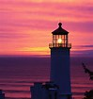](http://www.bing.com/images/search?q=lighthouse&id=7CDF0338A33FE351695866ECEF4F85BBE785291B&FORM=IQFRBA) [](http://www.bing.com/images/search?q=fireworks&view=detailv2&&id=8DAAA652DA91DB1D49F034F1F15ED034B313AD0E&selectedIndex=7&ccid=4Gxyo76H&simid=608044345154143170&thid=OIP.Me06c72a3be87fcdce047b74fcea810f4o0) [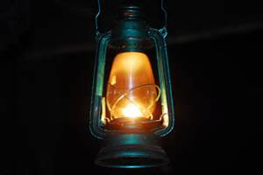](http://www.bing.com/images/search?q=sources+of+light&view=detailv2&&id=49E24EC9D2A41162034AC2B88B920F868C4117EE&selectedIndex=19&ccid=Mt%2b2Xeuf&simid=608015886694811151&thid=OIP.M32dfb65deb9feed9ca0a5ad57d81a21eH0) [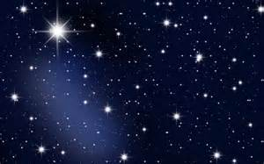](http://www.bing.com/images/search?q=stars&view=detailv2&&id=550F64B8A084606E57FC18900B7D45A51422B019&selectedIndex=23&ccid=6gkrJhX6&simid=608016131511488347&thid=OIP.Mea092b2615fa165de18a67f0957fa751o0) [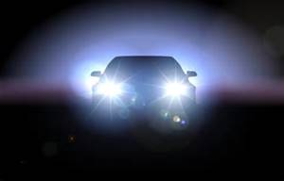](http://www.bing.com/images/search?q=head+lights&view=detailv2&&id=DBDF43DE504AE7275EC7A72872E4AB9E9492E8B3&selectedIndex=3&ccid=zFghVUb7&simid=608006463534007779&thid=OIP.Mcc58215546fb7af3d212425fc0c24f33H0) [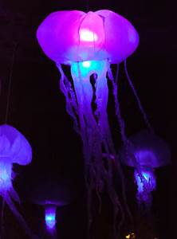](http://www.bing.com/images/search?q=sources+of+light&view=detailv2&&id=DE8DA1588FA278EE5D6583D045E59172624D0034&selectedIndex=10&ccid=mLFrWuv2&simid=608018416439463389&thid=OIP.M98b16b5aebf656d860969580a0c71959H0) [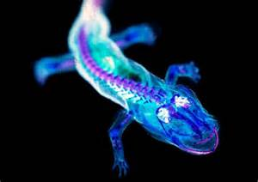](http://www.bing.com/images/search?q=bioluminscence+animals&view=detailv2&&id=B04F4192F6FA4CEC7B157F6F7DD49E58B423CDBF&selectedIndex=5&ccid=N67b7Qj9&simid=607992358868156971&thid=OIP.M37aedbed08fd14d55bf6394d66984e79o0)