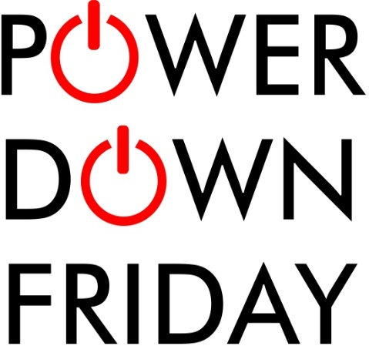

Sustainable Schools
Pemberton is working towards a 10% reduction in energy use from now to the end of the school year. This is a baby step in our efforts to transition our students, building, and habitats into a “Greener” way of working and doing things each day at school. As we transition into a Green School, we developing sustainable school goals that will continue each day all year and into the future to demonstrate we are an example for students and the community in striving to make changes that will have a positive impact on environment, Pemberton Community and our students.

- One of our sustainable school goals is to help consume less energy in our building to meet this goal we are lunching our first Power Down Friday as a reminder to turn everything off, unplug it, or hit the power strip button before leaving today. Please also unplug all appliances that don’t need to be on over the weekend.

- More than half of a building's energy use can be directly attributed to our daily choices with turning off lights and unplugging appliances. It's those seemingly small choices that can add up to a lot of energy savings!

So today and each Power Down Friday, remember to do these simple things at
the end of the day:
- Hit the Lights. Turn off lights, document cameras, and projectors in your room when leaving.
- Turn it Off. Appliances should be turned off, unless required to be on. (coffee pots, microwaves)
- Unplug it. Chargers and many small devices still draw electricity when they are off, if left plugged in. If you don't need it, unplug it.
Students and Green Committee members will be walking through to check rooms and leave treats for those that remember to Power Down! If we can meet our reduction of energy goals at Pemberton we may find that it could save us some money at home too.

